System Tips:

File Maintenance: Corrugated Style

| May-20 |

**Document Overview**

**Documentation Goals**

This documentation is intended to provide step-by-step instruction for ***Building or Changing Corrugated Styles in the Estimates System****.*

**Documentation Disclaimers**

* Provide instructions for how to look up current styles within the system.
* Provide instructions for how to update flutes and styles, as well as add new ones.
* Provide instructions for how to update dimension formulas.
* Provide instructions for how to update Routing information.
* Provide instructions for how to Choose, Update, and Create box designs.

**Table of Contents**

**Overview of Advantzware Specific Keys and Icons** 3

Function Keys 3

Advanced Software Standard Function Keys 4

Program Icons 5

**Steps to Build or Change Corrugated Styles** 6

1) Open the Corrugated Styles Screen [EB3] 6

2) Look Up Style by Code / Description 6

3) Select the Desired Flute 7

4) Update Style 8

5) RSC Scoring 9

6) Update Formulas 10

7) Update Routings 11

Routing Example 12

8) Box Design 13

Change Design Number 13

Box Drawings 14

# **Overview of Advantzware Specific Keys and Icons**

## Function Keys

|  |  |
| --- | --- |
| BRWS | The browser, which is a list of records in this file. This is functionally equivalent to the Find option of our standard package. |
| VIEW | View record provides the ability to ADD, CHANGE, DELETE, and UPDATE an individual record. |
| SORT BY | The selections at the bottom of the browser, which will sort the list alphabetic order. |
|  |  |
| Update | Update the current record. |
| Reset | Reset the current record. |
| Add | Add a record. |
| Copy | This will copy the existing record. |
| Delete | Delete the current record displayed on the screen. |
| Cancel | Cancel the information that was entered. |
| Save | Save the record. |
|  |  |
|  | Takes the user to the first current record. |
|  | Moves backward one record. |
|  | Moves forward one record. |
|  | Takes the user to the last current record. |
|  |  |
| F1 | Miscellaneous Fields |
| F3 | Search |
| F3 | List |
| F4 | Notes |
| F6 | Browse |
| F7 | Viewer |
| F12 | Exit |

## Advanced Software Standard Function Keys

|  |  |
| --- | --- |
| Next | Shows the next sequential record. |
| Prev | Shows the previous record. |
| Add | Add a record. |
| Change | Change the current record displayed on the screen. |
| Delete | Delete the current record displayed on the screen. |
| Find | Find a record by searching by description. |
| “1”, “2” | Number 1 or 2 to go the first or second page of this record. |
| Esc | Escape from the current transaction without updating. |
| Q | Quit from the current transaction without updating. |
| F1 | Save |
| F3 | Help information is available on every data field. Simply place the cursor on a field and press F3 to display documentation regarding this particular field. |
| F3 | To insert additional data in a data field without erasing the information currently displayed. |
| F4 | Notes – General |
| F1 | Field Lookup is available on every data field which is maintained in a separate file. Place the cursor on a field and press ***“F1”*** to search for the code by description or to advance a screen of records by pressing the next key. Place the cursor next to the desired record and press enter to transfer the record to the data entry screen. See ***“Page Up”*** / ***“Page Down”*** keys below as an alternative |
| F7 | Delete |
| F8 | Notes – File Specific |
| Enter | Advances the cursor to the next field |
| Page Up | Will skim forward through each record in a data file in sequential order |
| Page Down | Will skim backward through each record in a data file in sequential order |
|  |  |

## Program Icons

|  |  |  |
| --- | --- | --- |
|  | Job Notes |  |
|  | Customer Attachments | Attach files (such as Word/Excel/Images) for this specific customer order. |
|  | Change Move/Set Column Mode |  |
|  | Print Acknowledgement |  |
|  | Export to Excel |  |
|  | Add |  |
|  | Attachments | Attachments for this Estimate. Will transfer to all future repeat orders for this estimate. |
|  | Notes |  |
|  | Spec Notes | Notes for specific finished goods items. |
|  | Utility Application |  |
|  | Help |  |
|  | UDF Viewer |  |
|  | Commissions |  |
|  | Exit |  |
|  |  |  |
|  |  |  |

# **Steps to Build or Change Corrugated Styles**

## Open the Corrugated Styles Screen [EB3]

The user must navigate to the Estimating/Quotes -> Build Estimate Files -> Corrugated Styles screen system. To do so, the user may click on each menu line, or press the ***“E” – “B” – “3”*** Hot Keys to open the screen.

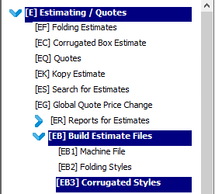

## Look Up Style by Code / Description

On the ‘Browse Style’ screen, the user may sort the list of available styles by the Style Code Number, or by the Style Description. Alternatively, if the user knows the style number or description they wish to search for, they may enter into in the ‘Auto Find’ field to narrow down the list of available styles.



Click on the desired style in order to highlight it within the list. The style highlighted on the ‘Browse Style’ screen will be the style that all subsequent screen tabs will show information from.

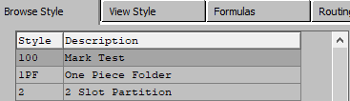

## Select the Desired Flute

With the chosen Style highlighted. Click on the ‘View Style’ screen to view detailed information about the chosen Style. The user may use the arrows keys to move to the desired Flute for this style.



Once viewing the chosen Flute, click the ***“Update”*** button to edit the details. Alternatively, the user may click the ***“Add”*** button to create a new style from scratch, or the ***“Copy”*** button to change only what is different for a new Style (which is intended to save the user time).

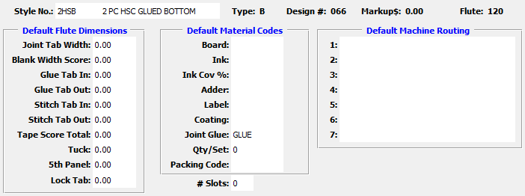

## Update Style

If the user has chosen the ***“Update”*** or ***“Add”*** option, they can modify the Style data.

Clicking in the ‘Joint Tab Width’ field will allow the user to change the tab size. (Corrugated materials automatically default to the decimal 16ths, so a value of 1.08 is a 1½ inch tab.)

Clicking in the ‘Blank Width Score’ field will cause the ‘Blank Width Score Detail’ popup window to display on the screen. The fields within this window allow the user to input (or override) the scoring for the blank width. To include a specific scoring profile for each panel, the user may also choose a ‘Type’ from the drop-down list of options next to their chosen panel.

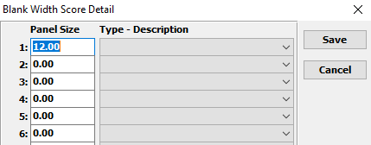

Once all scoring measurements have been detailed, the user must click the ***“Save”*** button in order to save all changes to the popup screen.

The next panel (‘Glue Tab In’) will immediately pop up for any potential modifications the user wishes to make. The rules for making changes to the data within this window are the same as the ‘Blank Width’ screen.

The same will be true for all subsequent fields. Each time a user finishes with one detail screen, the next in the sequence will pop up for any potential modifications.

### Save Changes

Once the user has updated all the scoring and panel data for this Style, they must click the ***“Save”*** button to save the changes before moving on.

Alternatively, the user may select the ***“Reset”*** button to reset all data fields for this style back to their original measurements. For a brand-new style, this will reset all fields back to the initial 0.00 dimensions. For a style that is currently being updated, these fields will revert back to the measurements they had before the user began making changes.

Selecting the ***“Cancel***” button, will cancel all changes to the current style without saving. For a brand-new style, this will delete the unsaved style from the system. For a style that is currently being updated, it will revert all fields back to the measurements they had before the user began making changes, and stop the update.



## RSC Scoring

As the user would need to repeat the above process for each Flute within this style, it may be easier to start with the RSC Scoring, and then use the ***“Scores”*** button to copy these scores to other box styles.



For example, the user may wish to set adjust the scoring for all tab and panel configurations. You may run an RSC

1. ‘Tab’ – ‘L’ – ‘W’ – ‘L’ – ‘W’
2. ‘Tab’ – ‘W’ – ‘L’ – ‘W’ – ‘L’
3. ‘L’ – ‘W’ – ‘L’ – ‘W’ – ‘Tab’
4. ‘W’ – ‘L’ – ‘W’ – ‘L’ – ‘Tab’

Then, use the ***“Score”*** button to move the scores to another style (such as the HSC). Of course, the user would still need to go to the HSC style and adjust the Width scores, since there is once less width panel.

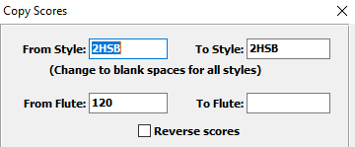

## Update Formulas

The ‘Formulas’ tab indicates the sequence of the inside dimensions across the length and width panels. The ‘S’ at the end of the formula is simply a flag to tell the program that there are no additional dimensions to follow.



The ‘Square Feet’ panel data is typically the same as the layout formula. The ‘KDF’ (Knocked Down Flat) dimensions are used for palletization calculation, so they reflect the folded blank size.

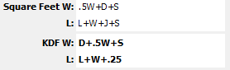

To change the formulas, the user must click the ***“Update”*** button.



When the user saves the changes to this screen, it will update the new formulas to all Flutes within this style.

If the user needs to change the panel configurations for this style, (For example, if the FOL length was ‘J’+’W’+’L’+’W’+’L’) then the user must change the formals on this page to reflect that.

## Update Routings

The ‘Routing’ tab is used to establish defaulted Routing. This feature is optional, but the benefit is that the defaulted Routing will then automatically be used when estimating the style of carton.

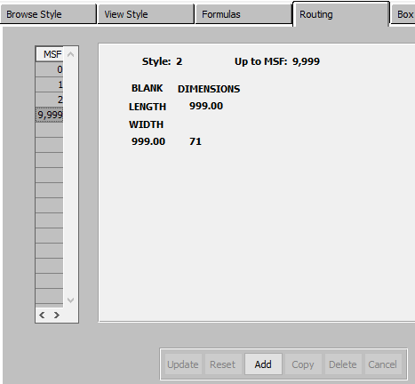

To use this feature, the user would need to first have built a listing of all potential routings in the Routing Table, located in the ‘Machine Routings’ program [EB!].

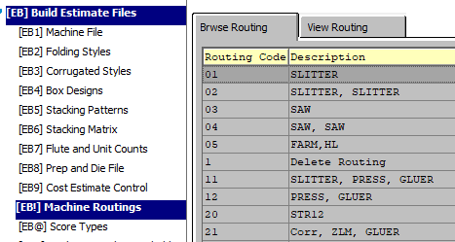

### Routing Example

In the following example, there are established routing criteria based upon the total MSF being estimated (up to MSF) and blank size of the carton.

As you can see, different routing combinations are then defaulted based upon the blank length and width. Each number in this matrix represents a potential routing sequence from the routing file [EB!] above.  Therefore, it is critical to know the machine min and max sizes for each machine in the potential route so that it can be place in the appropriate up to length and width position in the matrix on the style routing tab.

As an example, routing 21 is “Slitter, ZLM, Gluer” as can be seen in the screen capture above.  The slitter was included since this routing is for orders up to 3 MSF (you can have different routing for any MSF break desired).

Different routings are suggested at different intersection blank widths and widths (based on the machine limits).  Routing 99 says “Buy outside” since there are no machines in my company that will run these intersecting blank sizes.

We suggest that you build routing for one carton style (such as an RSC) and then use the copy button to copy this routing to other carton styles (FOL, HSC).

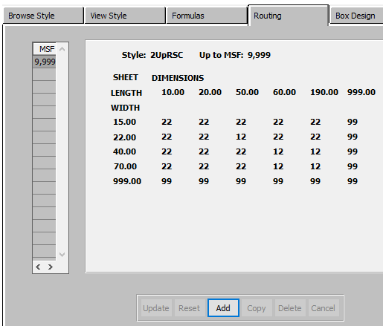

## Box Design

The box drawing that is associated with the style is visible from the ‘Box Design’ tab.  If you have changed the formulas to reflect different panel configurations (for example form ‘W’ – ‘L’ vs ‘L’ – ‘W’) you will need to associate a different design number to associate with this style.

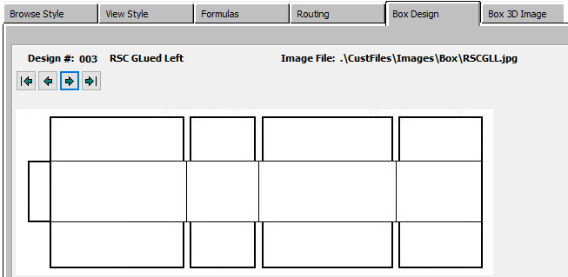

### Change Design Number

The design number can be changed on the View Style tab in [EB3].  But before changing it, let’s discuss what drawing is attached to each design number.

### Box Drawings

From the main menu go to [EB4], Box Designs. In Box Design select the design number that was related to the style you were working on.  You can then view, and / or associate a different box drawing if necessary or add a new design number if desired.

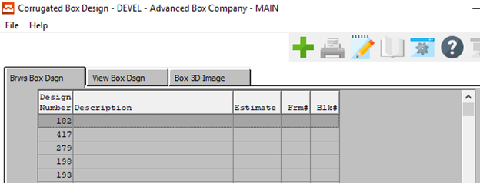

On the ‘View Box Design’ tab, the user will see the associated drawing for the selected design number. In ***“Update”*** mode, the user can position your cursor in the ‘Image File’ field and look up all the available images to associate with this box design.

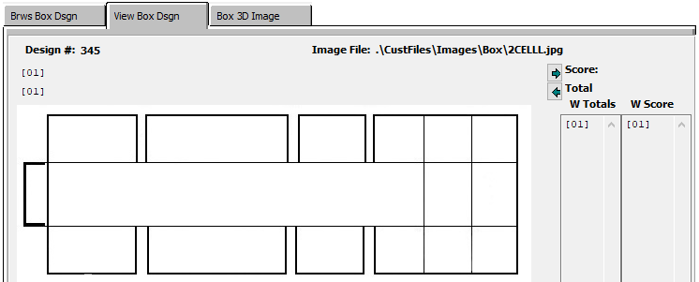

To view any other potential box drawings, press the ***“F1”*** key while your cursor is in the Image File field.

We would suggest that you view the box images as thumbnail images so that you can easily associate a new drawing if you so desire.

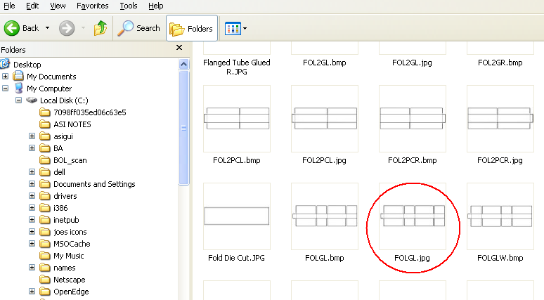

At this point you can either associate the new image with this design number, or you can add a new design number and attach a new drawing to it.  If you change the drawing, then the design number will remain the same in your style file.

You can also go to Windows explorer for the directory listed in the design file:



Then, select a design, double click it, and modify it with your JPG editor (usually MS Paint) and save it. You could also create a new design and save it to this same directory.

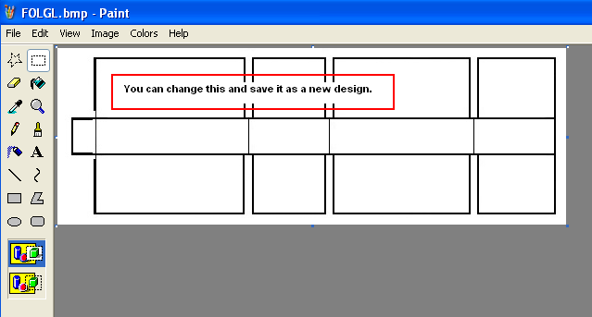

The user can also change the 3-D Image associated with this box design by following the same procedure on the Box 3D Image Tab.

